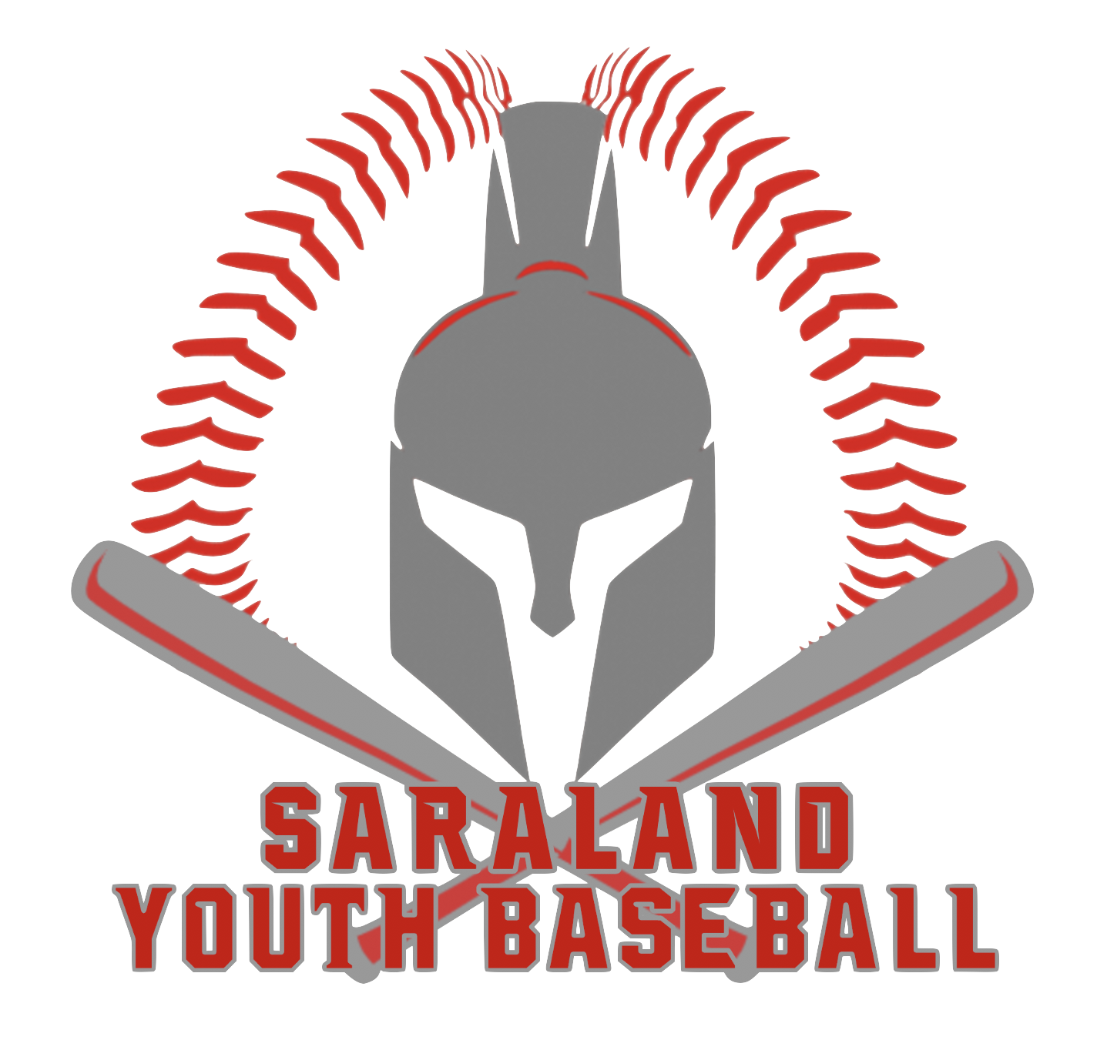

# SARALAND YOUTH BASEBALL

# SPONSORSHIP PROGRAM

# BASE HIT LEVEL $175: This level provides the sponsor an

# 18” x 12” sign that will be displayed on our sponsor board located in the middle of the park for all to see. $100 will go to the team of your choice and the remainder will go to purchase the sign. If the sponsor chooses to donate a second year and subsequent, consecutive years then the price is discounted to $125 with all proceeds going to the team of their choice.

# WALK OFF HOMERUN LEVEL $350: This level provides the sponsor a 4’x 8’ sign displayed along the outfield fence as well as the sponsor’s logo on our website with a link to their site. Outfield signs will be green with white letters/logos to keep the field uniform. $250 goes to the sponsored team with the remainder going to purchase the sign. If the sponsor chooses to donate a second year and subsequent, consecutive years then the price is discounted to $275 with all proceeds going to the sponsored team.

# GRAND SLAM LEVEL $550: With this level one of the baseball fields will be named after the sponsor. A large sign will be prominently displayed on the press box and state “This field is sponsored and maintained by <Your Company Name>” as well as having your logo on the sign. If the sponsor chooses to donate a second year and subsequent, consecutive years then the price is discounted to $500.

# If a sponsor chooses not to have a sign, then there is no minimum amount and all proceeds will go to the team of their choice.

# A high-resolution logo will need to be emailed to SaralandYouthBaseball@gmail.com with your company’s name and “logo” in the subject line.

# Make sponsorship checks out to Saraland Dixie Youth.

# PO Box 1007 Saraland, AL 36571

# Our Tax ID is 27-2164869